Narrative Point of View Comic Strips

Objective: create three comic strips (3 panels each = 9 panels) showing three different narrative viewpoints.

Requirements

1. Each comic strip will contain dialogue (word bubbles) and narration (square narration boxes).
2. Each comic strip should be narrated using the following perspectives: first-person, second-person, and one of either third-person objective, third-person limited, or third-person omniscient.
3. Make an effort. If you are not good at drawing, create good storylines and use stick men.

*If you decide to work with a partner, you will make FIVE comic strips (one for each POV = 15 panels) and color them.*
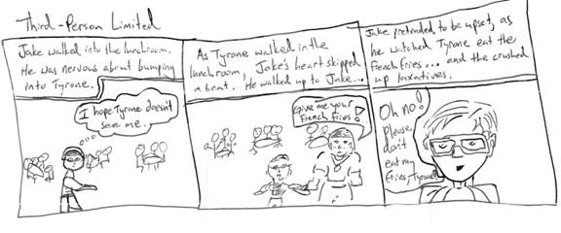
Rubric: TOTAL (20 + 10 bonus possible): __________/20 – Rubric MUST be turned in with project or -5 pts

Knowledge: Did you label the narrator's view point correctly in each comic strip?
^{1) Doesn’t understand} | ^{2) Made a few mistakes} | ^{3) Made more than 2 mistakes} | ^{4) Made one or two mistakes} | ^{5) Well done – No mistakes!}
Completion: Did you make 3 (5 for partners) comic strips? Did you add narration, dialogue, and pictures?
^{1) Mostly incomplete} | ^{2) One strip complete} | ^{3) Two strips complete} | ^{4) Only 1 or 2 items missing} | ^{5) Fully complete}
Quality: Did you attempt to create a good story, nice pictures, or both?
1) Very sloppy, nearly illegible | 2) Quality is not at grade level | 3) Started off strong, but rushed at the end | ^{4) Mostly quality work} | ^{5) High-quality work}
Effort: Does your completed project reflect an appropriate amount of effort?
1) Very little effort applied to project | ^{2) Shows only moderate effort} | 3) Shows sufficient effort, but could have done better | ^{4) Shows sufficient effort`} | 5) Shows extreme effort – GREAT WORK!

Bonus Opportunity: Use each BVS.3.13 term one time for up to 10 bonus points!!!

